TECHNICAL STANDARD OPERATING PROCEDURE
CREATING A NEW WINDOWS SERVER 2016 INSTANCE ON VMWARE Workstation
Prepared by: Capgemini India
Prepared for: Larsen & Toubro (L&T)

Document Version / Revision History
Version | Revision Date | Status & Description | Author | Reviewer | Remarks
1.0 | 11/10/2026 | Initial Draft: Windows Server 2016 basic setup procedure on VMware. | Nishant Khetal | Luvv Jain | Initial Submission

Table of Contents
Contents
1. Preface 4
2. Document Content Overview 4
3. Resource Requirements 4
3.1 Hardware Resource Allocations 4
3.2 Software & ISO Requirements 4
4. Operational Prechecks 4
5. Actual Procedure: Step-by-Step Guide 5
6. Post-Activity Infrastructure Checks 18
7. Verification & Deliverables Confirmation 18
8. Conclusion 19
9. Official References & Licensing Links 20

1. Preface
This technical document establishes the standard operating procedure for deploying a Windows Server 2016 instance within the VMware workstation enterprise environment. This framework guarantees operational alignment and architectural consistency across the infrastructure shared between Capgemini and Lars & Toubro (L&T).

2. Document Content Overview
This guide outlines the hypervisor configuration, virtual hardware provisioning, and operating system deployment required to establish an enterprise-ready Windows Server 2016 node. It details specific settings, interface prompts, and post-installation checklists necessary for baseline network integration.

3. Resource Requirements

3.1 Hardware Resource Allocations
- Compute: Minimum 1 vCPU (Virtual Central Processing Units.
- Memory: Minimum 4096 MB (4 GB) vRAM (virtual Random Access Memory).
- Storage: Minimum 60 GB virtual disk space.

3.2 Software & ISO Requirements
- Hypervisor: VMware workstation 17 or newer managed via vCenter Client interface.
- Operating System: Official Microsoft Windows Server 2016 Standard Edition 64-bit ISO image file.
- ISO Integrity: SHA-256 verified media located in the global datastore ISO repository.

4. Operational Prechecks
- Verify target workstation has sufficient free RAM (minimum 8 GB uncommitted) and CPU capacity to handle the load.
- Confirm that the target L&T VLAN port group has DHCP enabled, or obtain an allocated static IP address, subnet mask, and default gateway from the network team.
- Ensure that the official Windows Server 2016 ISO file is available and accessible for mounting in VMware Workstation.

5. Actual Procedure: Step-by-Step Guide
Step 1: Open VMware Workstation and select the My Computer tab to view the virtual machine library.
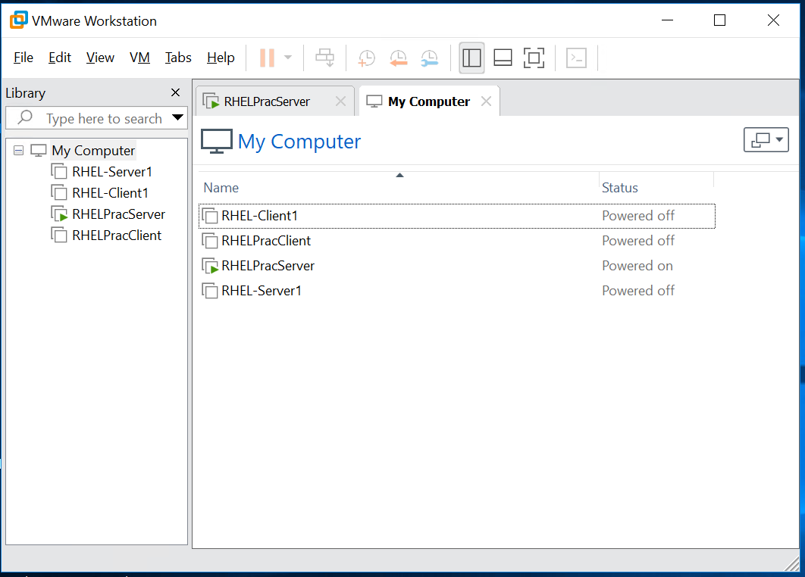
Step 2: In the left-hand Library pane, right-click My Computer and select New Virtual Machine… to launch the configuration wizard.
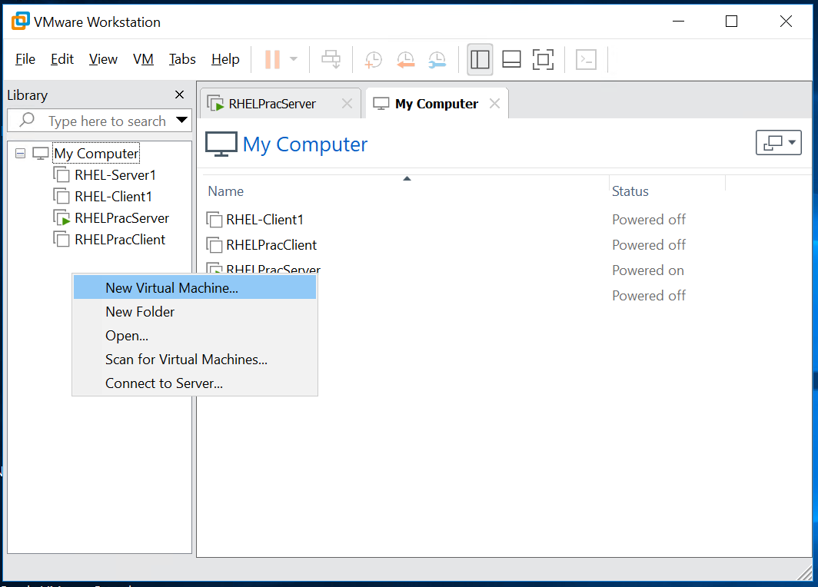

Step 3: In the New Virtual Machine Wizard, select Custom (advanced) and click Next to configure the virtual machine's hardware settings.
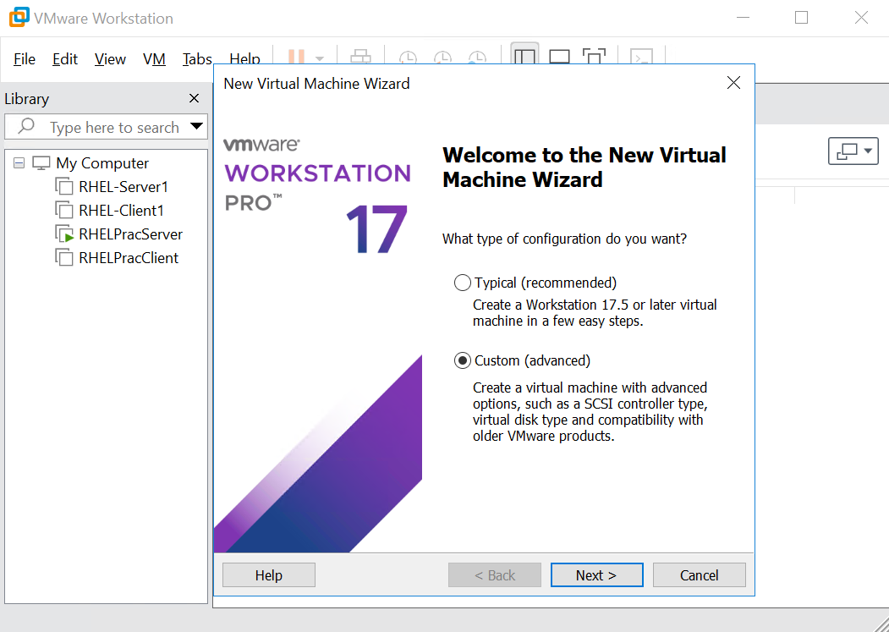
Step 4: Select Workstation 17.5 or later from the Hardware compatibility dropdown list and click Next.
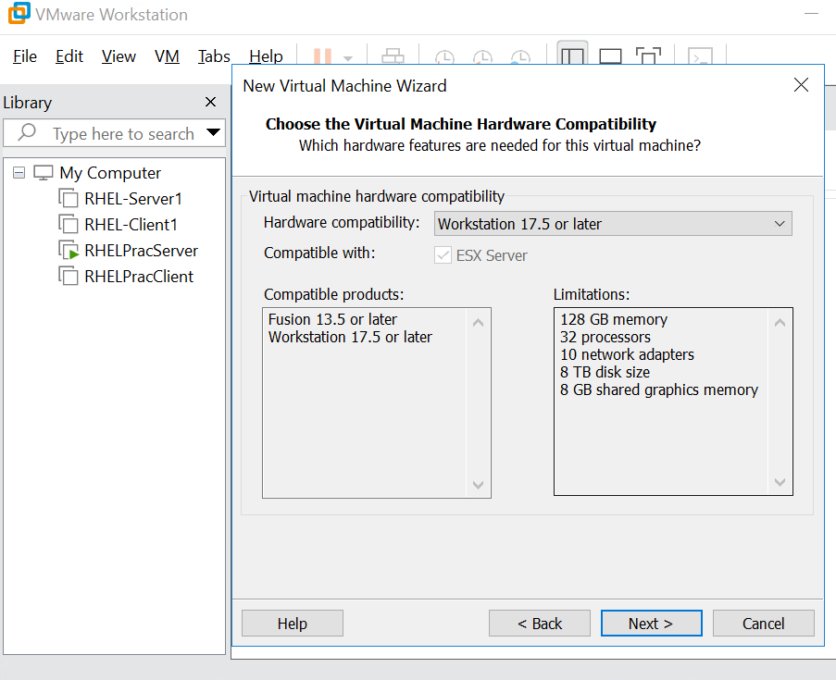
Step 5: Select the Installer disc image file (iso) option, click Browse, and locate the official Windows Server 2016 ISO file. Select the file and click Next.
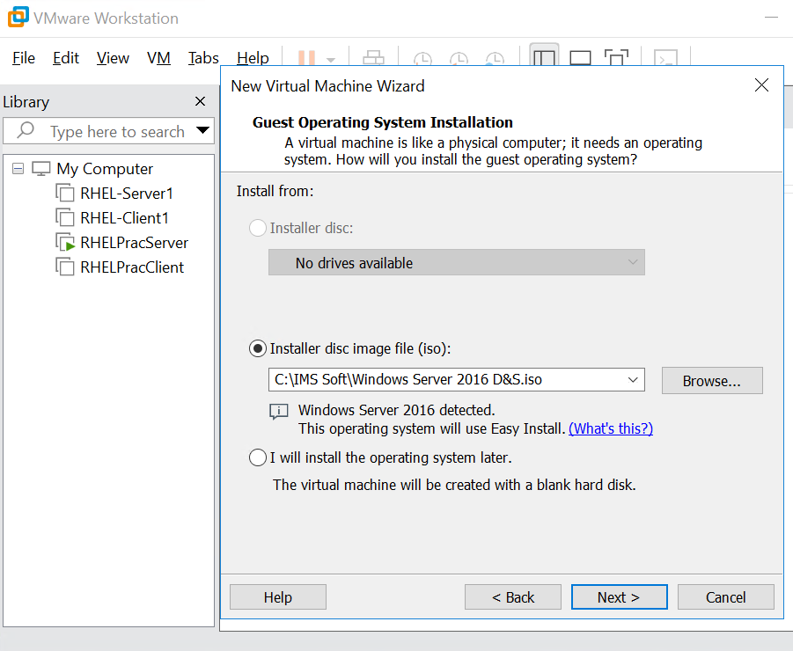
Step 6: Review the Windows Server installation details. Enter the required full name, set a strong administrator password, confirm the password, and click Next.
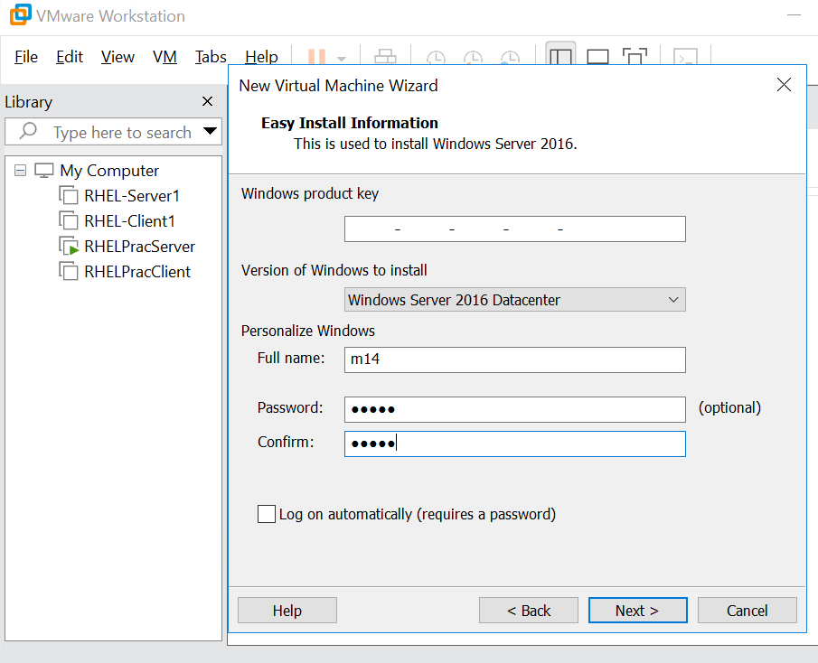
Step 7: Enter a unique name for the virtual machine, such as L&T_Windows_2016_VM
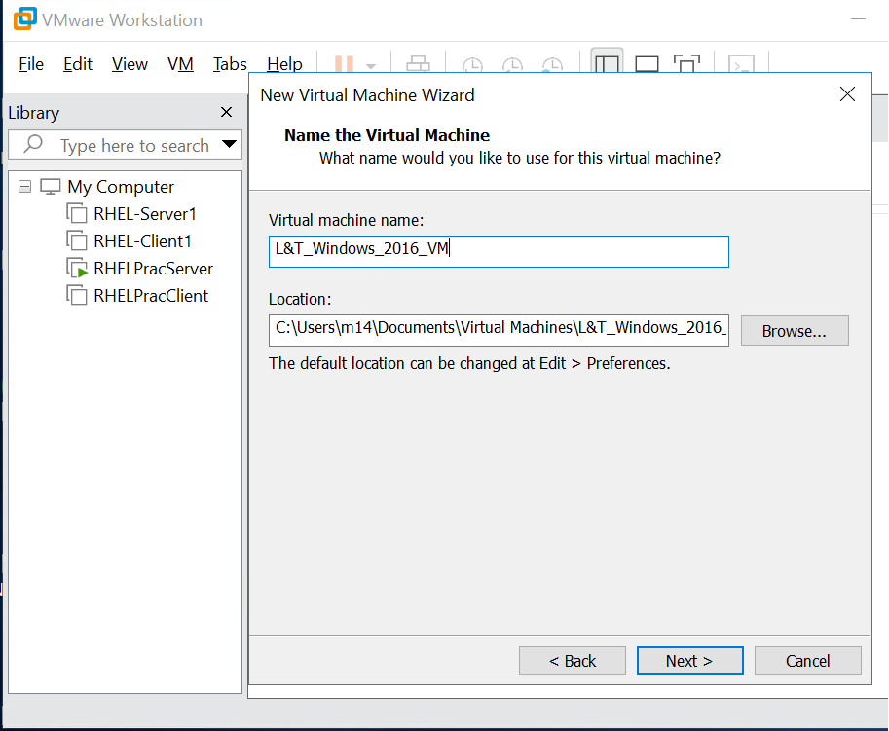
Step 8: Select BIOS as the firmware type for the virtual machine, then click Next.
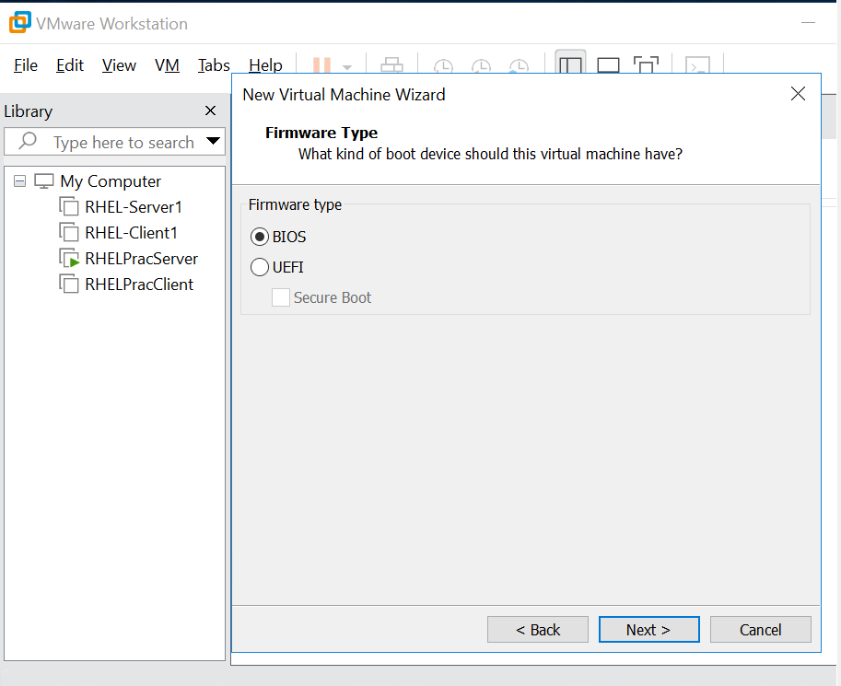
Step 9: Specify the processor configuration by setting the number of processors to 1 and the number of cores per processor to 1.
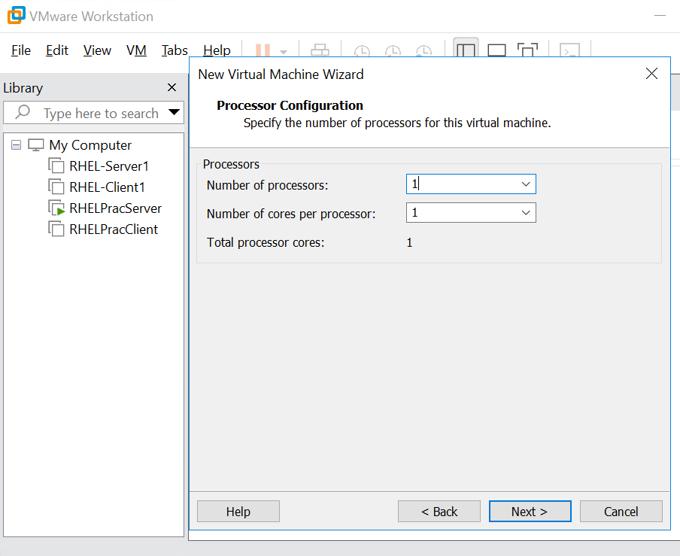
Step 10: Allocate 8192 MB (8 GB) of memory to the virtual machine by entering the value in the memory field, then click Next..
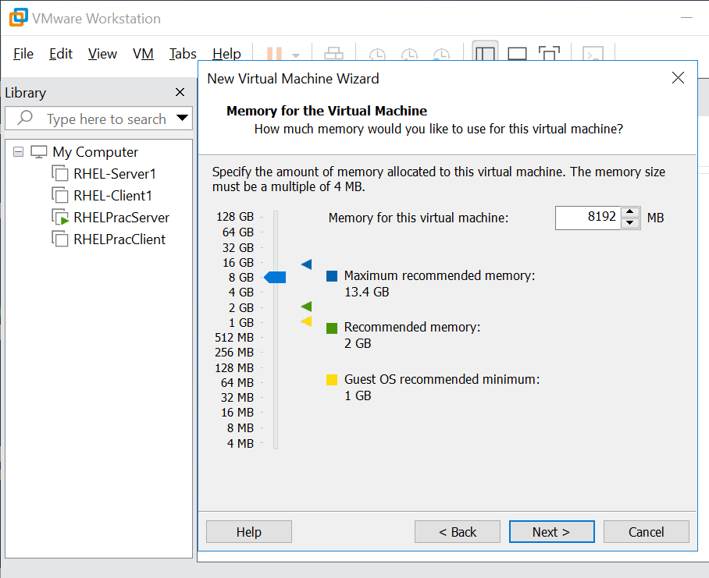
Step 11: Configure the virtual machine's network connection by selecting Use network address translation (NAT), then click Next.
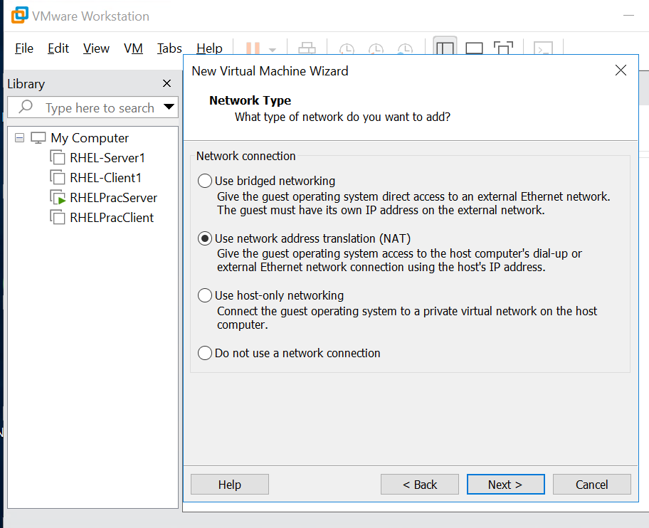
Step 12: Select LSI Logic SAS from the SCSI Controller I/O types list, then click Next.
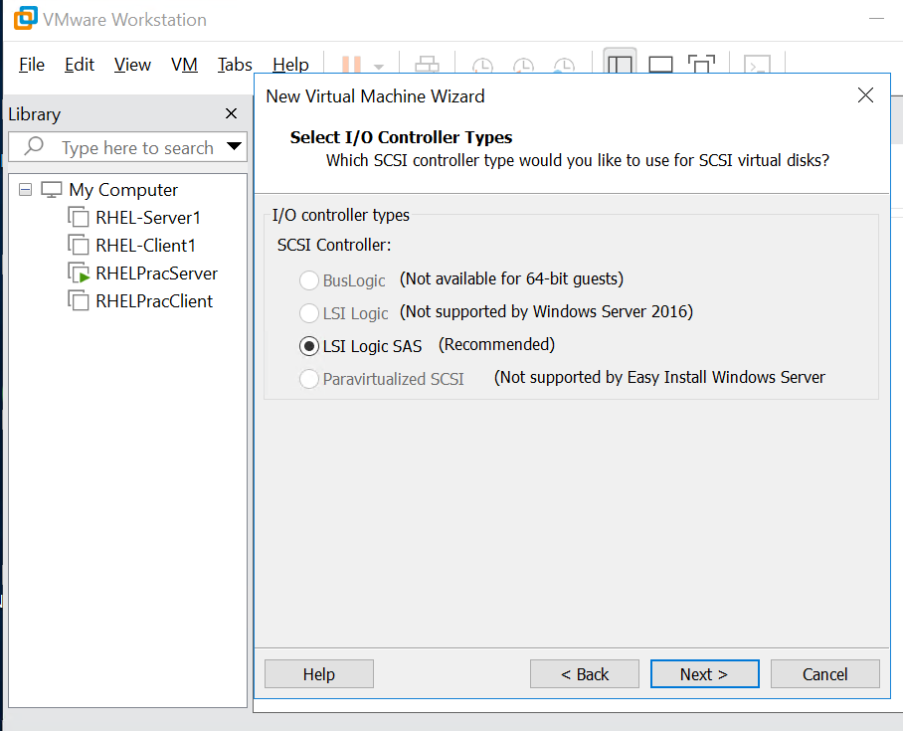

Step 13: Under the Select a Disk screen, choose Create a new virtual disk and click Next to configure storage for the virtual machine.
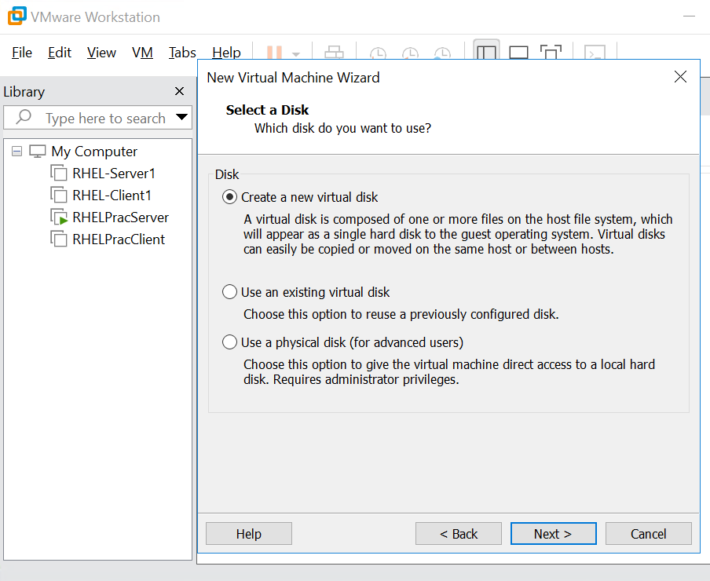
Step 14: Set the maximum disk size to 100 GB, select Store virtual disk as a single file, and click Next.
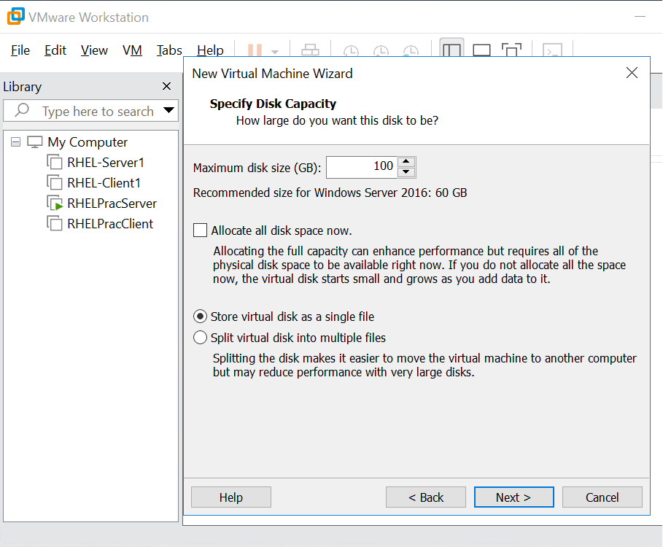
Step 15: Retain the default virtual disk filename, L&T_Windows_2016_VM.vmdk, or specify a suitable filename if required. Click Next to continue.
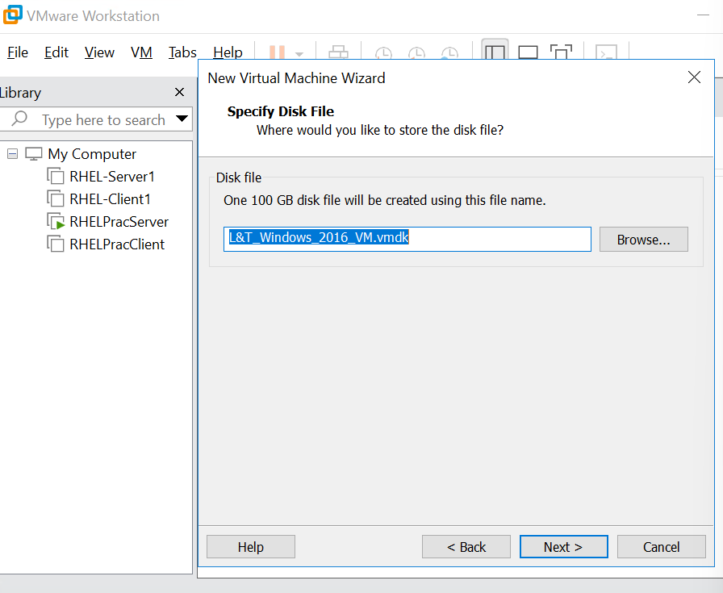
Step 16: Review the virtual machine configuration summary. Verify the name, operating system, memory, disk capacity, and network settings. Ensure that Power on this virtual machine after creation is checked, then click Finish.
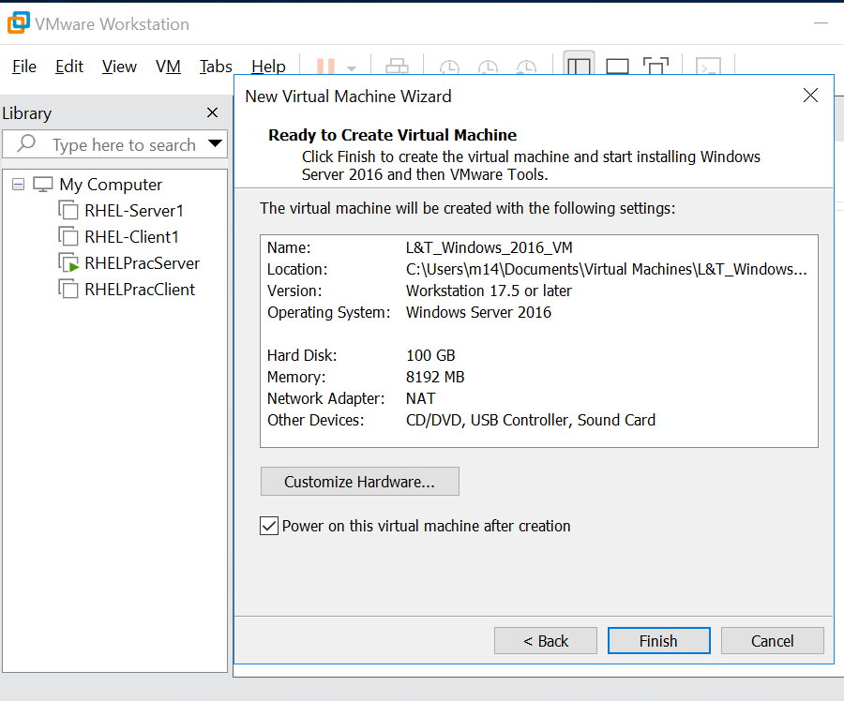
Step 17: Observe the virtual machine as the Windows Server operating system begins to load and displays the Windows startup logo.
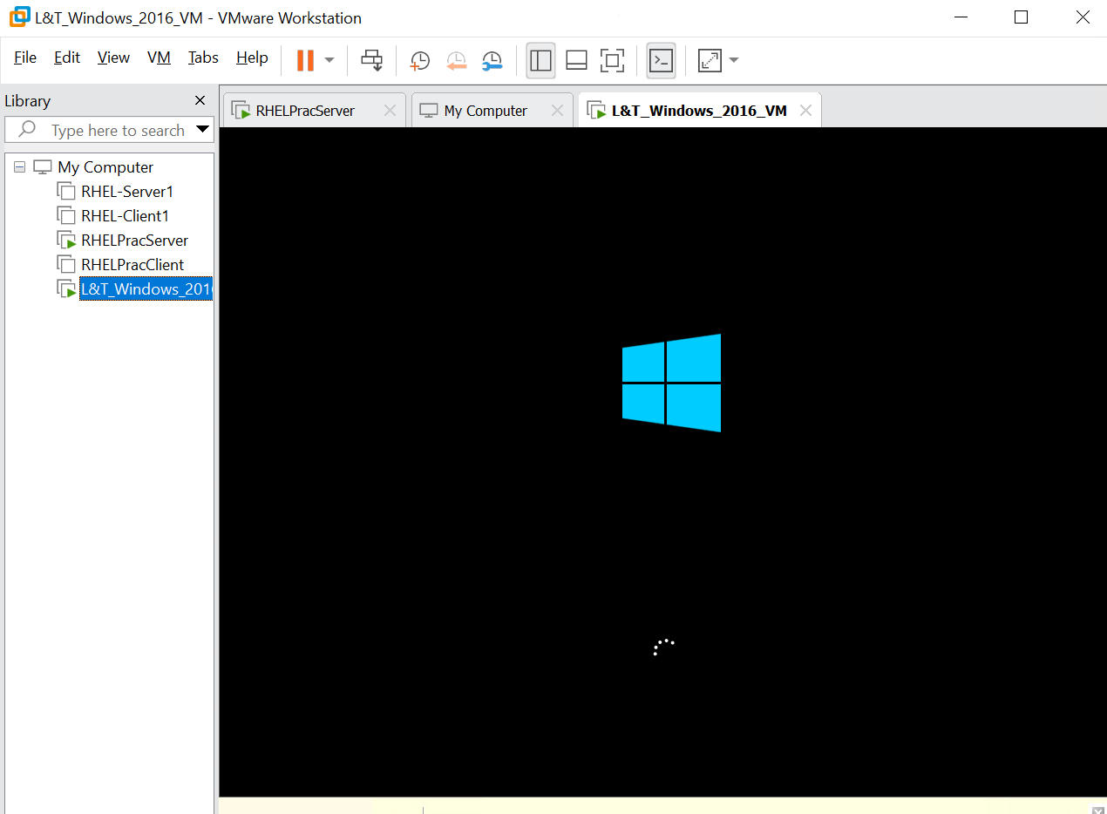
Step 18: Wait for the setup initialization screen to appear and display the message “Setup is starting.”
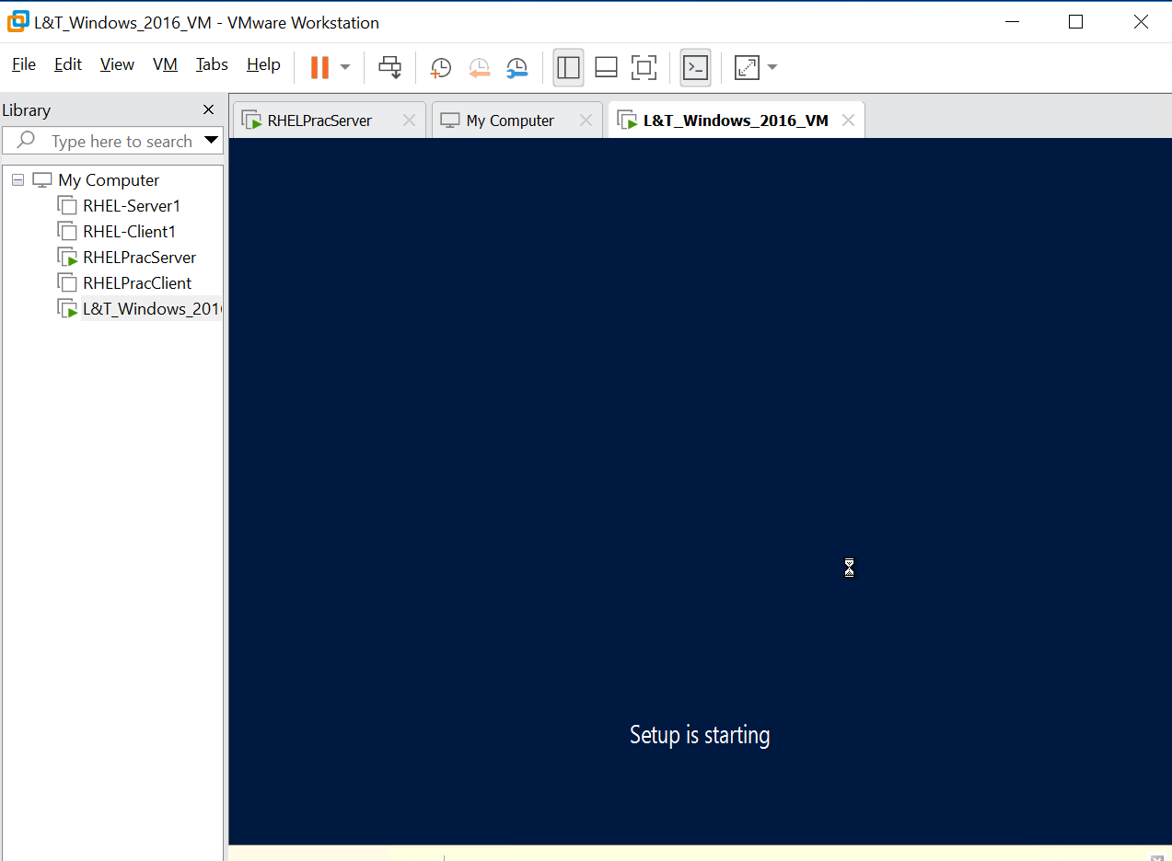

Step 19: Select the required Windows Server 2016 edition from the installation options. In this procedure, select Windows Server 2016 Datacenter (KMS), as shown in the screenshot
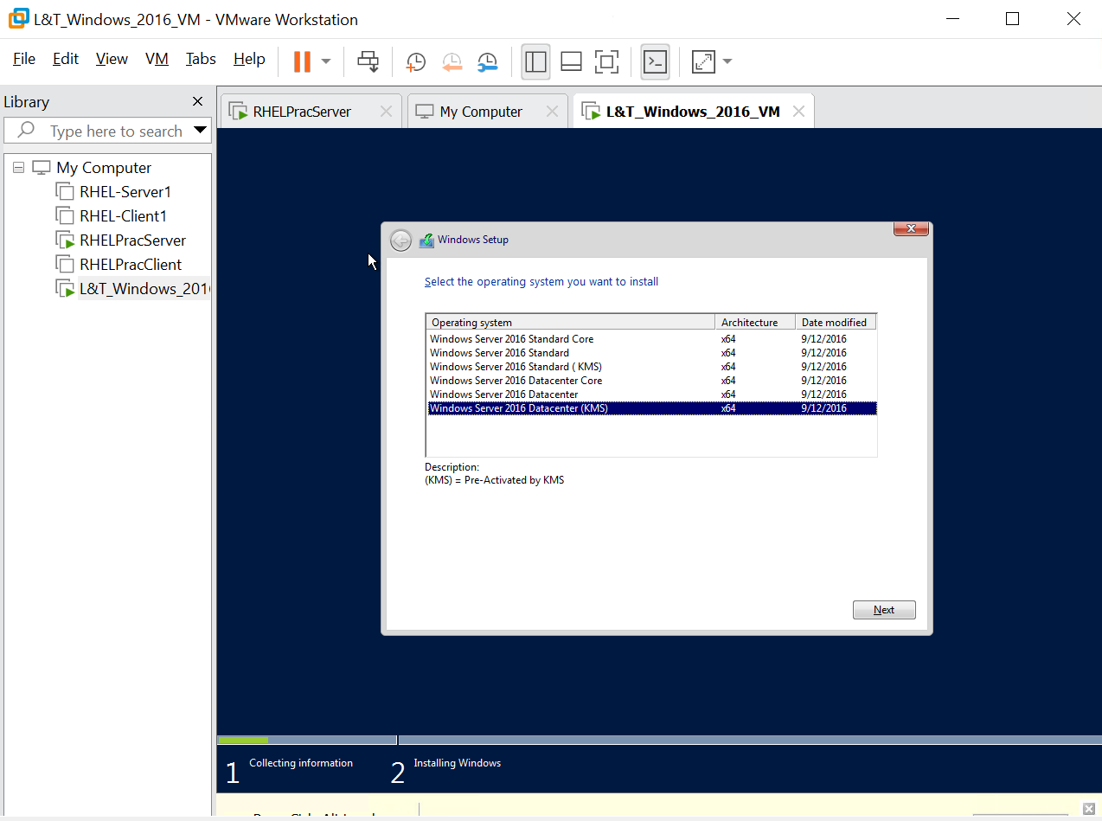
Step 20: Monitor the Windows Setup progress screen while the operating system files are copied and the installation components are installed. Wait for the installation process to complete.
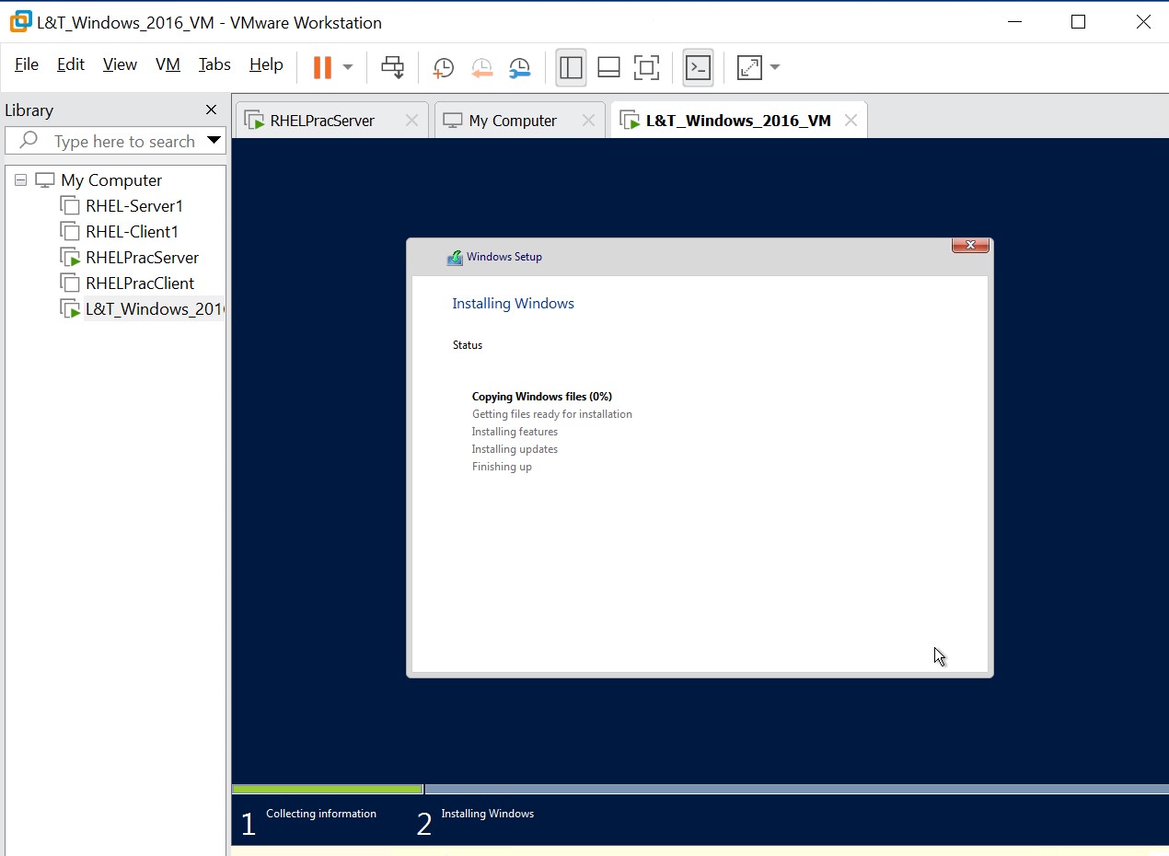
Step 21: Verify that Windows Server starts successfully and displays the Server Manager Dashboard.
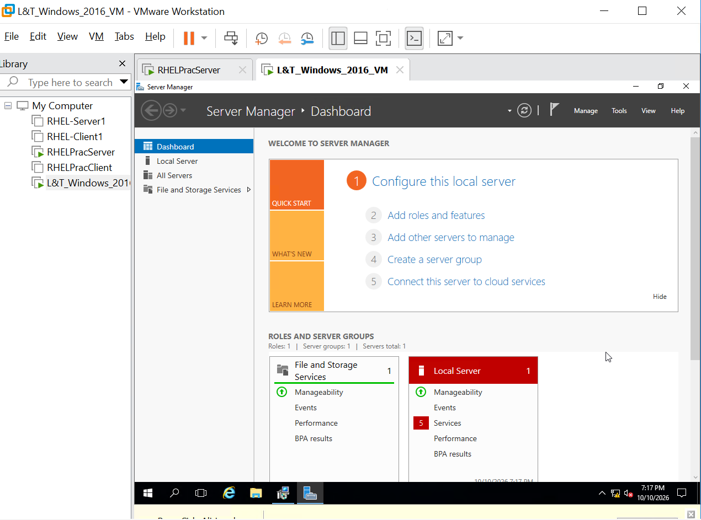
Step 22: Open Local Server in Server Manager and review the server properties, including the computer name, workgroup, operating system edition, and current configuration settings.
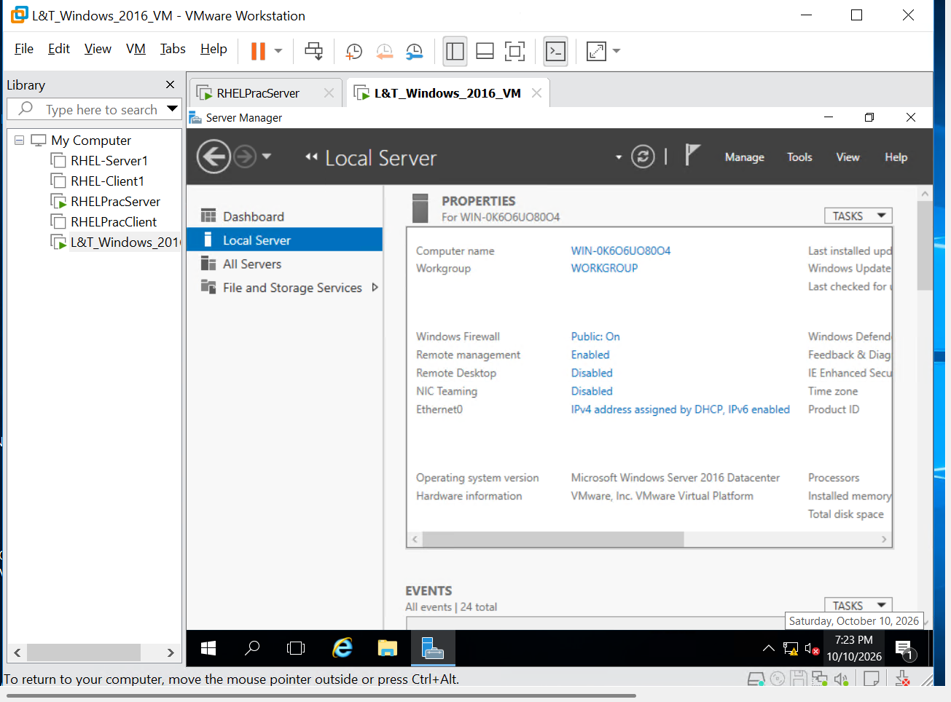
Step 23: Open the network adapter's properties, select Internet Protocol Version 4 (TCP/IPv4), and click Properties. Select Use the following IP address to configure a static IPv4 address.
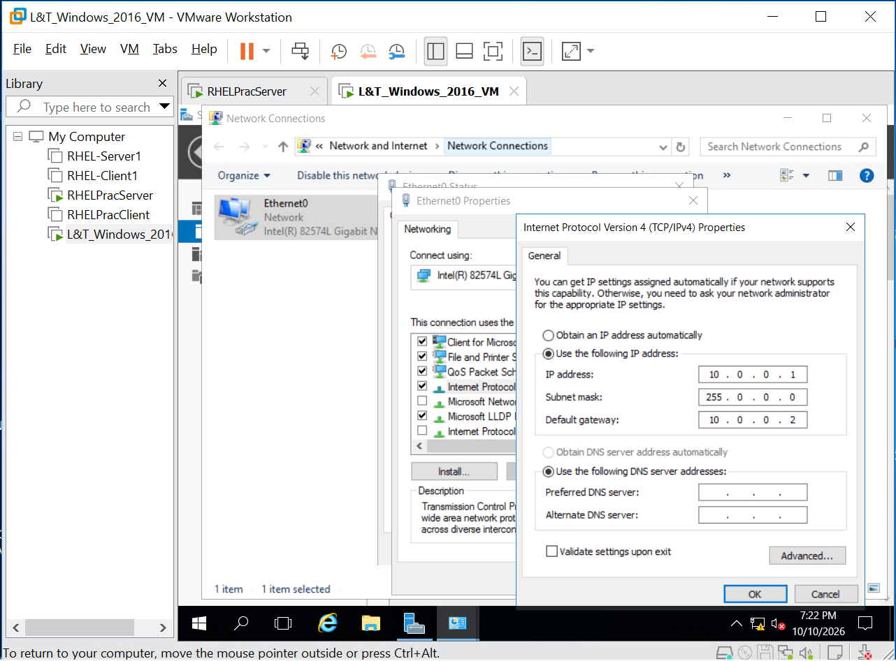
Step 24: Enter the approved static IP address, subnet mask, default gateway, and DNS server addresses provided by the network administrator. Click OK to apply the settings, then verify the updated configuration.
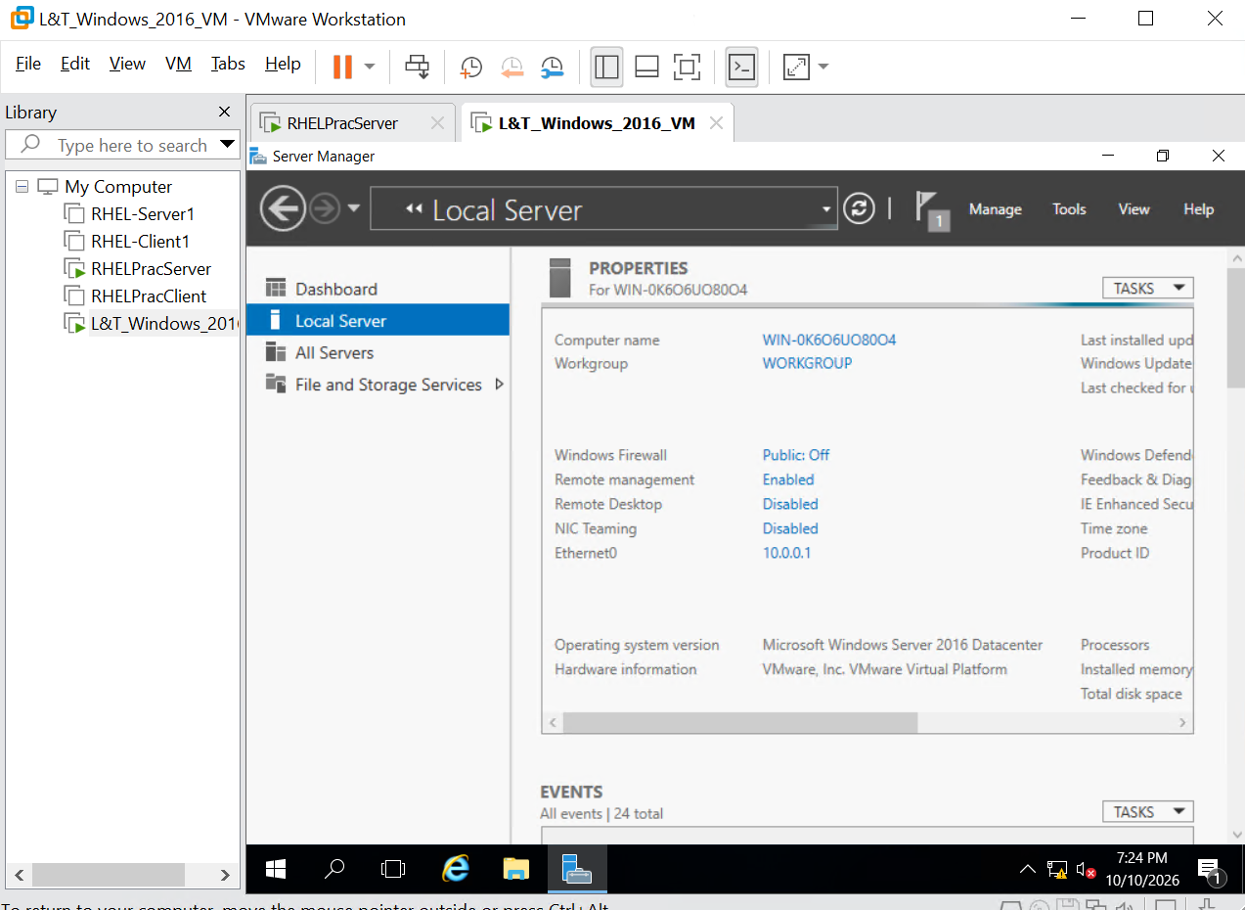
Step 25: Open the Windows search menu, type cmd, and select Command Prompt to launch the application.
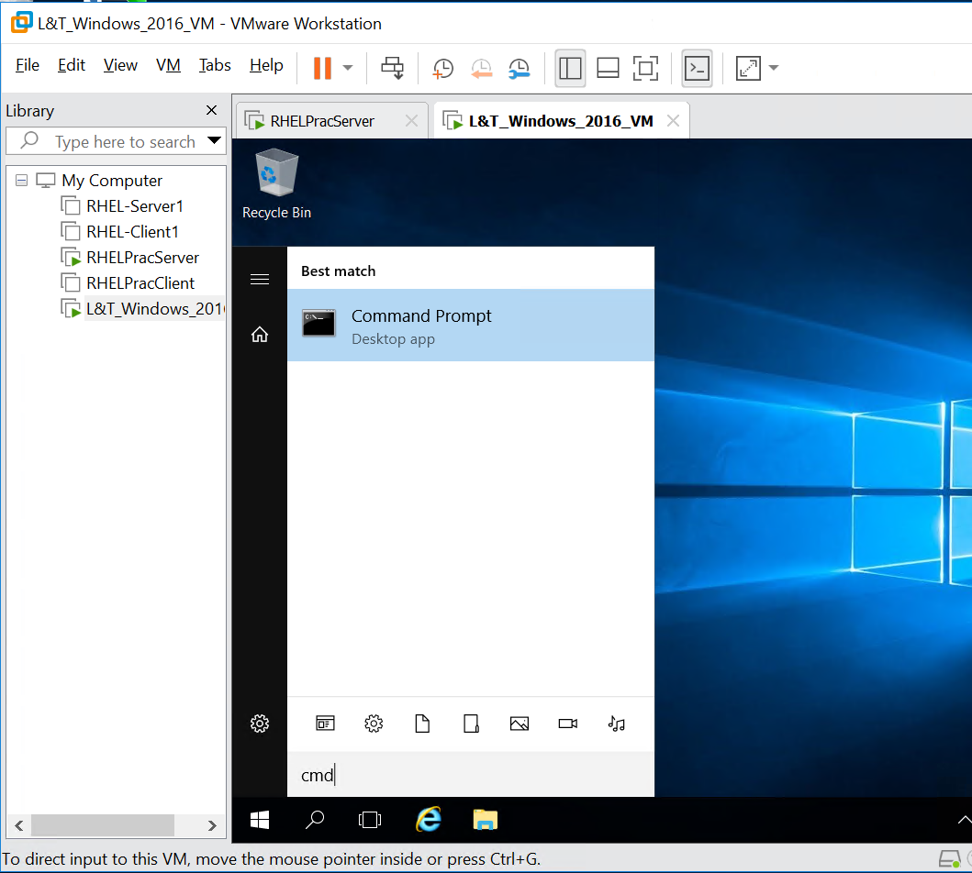
Step 26: In Command Prompt, execute ping 10.0.0.1 to test connectivity to the configured IP address. Verify that replies are received and check the packet-loss statistics.
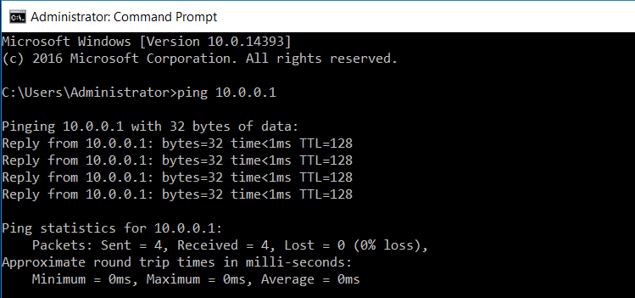

6. Post-Activity Infrastructure Checks
- Confirm that the virtual machine boots successfully without hypervisor errors or driver conflicts.
- Verify the guest operating system's network configuration using ipconfig.
- Test connectivity to the configured default gateway or another reachable host, where applicable.
- Review the ping results and confirm that packet loss is within acceptable limits.

7. Verification & Deliverables Confirmation
Capture a final screenshot showing the running Windows Server desktop and the Server Manager – Local Server properties panel. Verify that the operating system is running and that the displayed configuration matches the intended setup.

8. Conclusion
Following this procedure, a Windows Server 2016 virtual machine has been created and its basic configuration verified in VMware Workstation. The successful startup and verification checks provide a foundation for further configuration, security hardening, and domain integration, as required by the target environment.

9. Official References & Licensing Links
- VMware Workstation Documentation
Official documentation for virtual machine creation, hardware configuration, and guest operating system compatibility.
https://docs.vmware.com/
- Microsoft Windows Server 2016 Documentation
Official guidance for Windows Server installation, configuration, and administration.
https://learn.microsoft.com/en-us/windows-server/
- Microsoft Windows Server Licensing
Official licensing information for Windows Server editions and activation requirements.
https://www.microsoft.com/licensing/

